! Dear Customer please choose a part of this document that is particular to the product you purchased.

Disclaimer
This document is the property of Landyair and should not be redistributed or replicated / reprinted , it is for the sole use of visual reference of landyair customers. Please consult with your vehicles workshop manual and take all necessary precautions with regard to protecting your safety whilst working on your vehicle !protecting yourself and your vehicles systems from damage, the information below as been collated from our own personal & customer experiences and should be used as a guide only, we are not qualified motor vehicle repairers and we advise that you research the task in hand before commencing with your repair .
=====================
LandyAir - Audi Allroad
Wabco Compressor Piston Seal Repair Kit

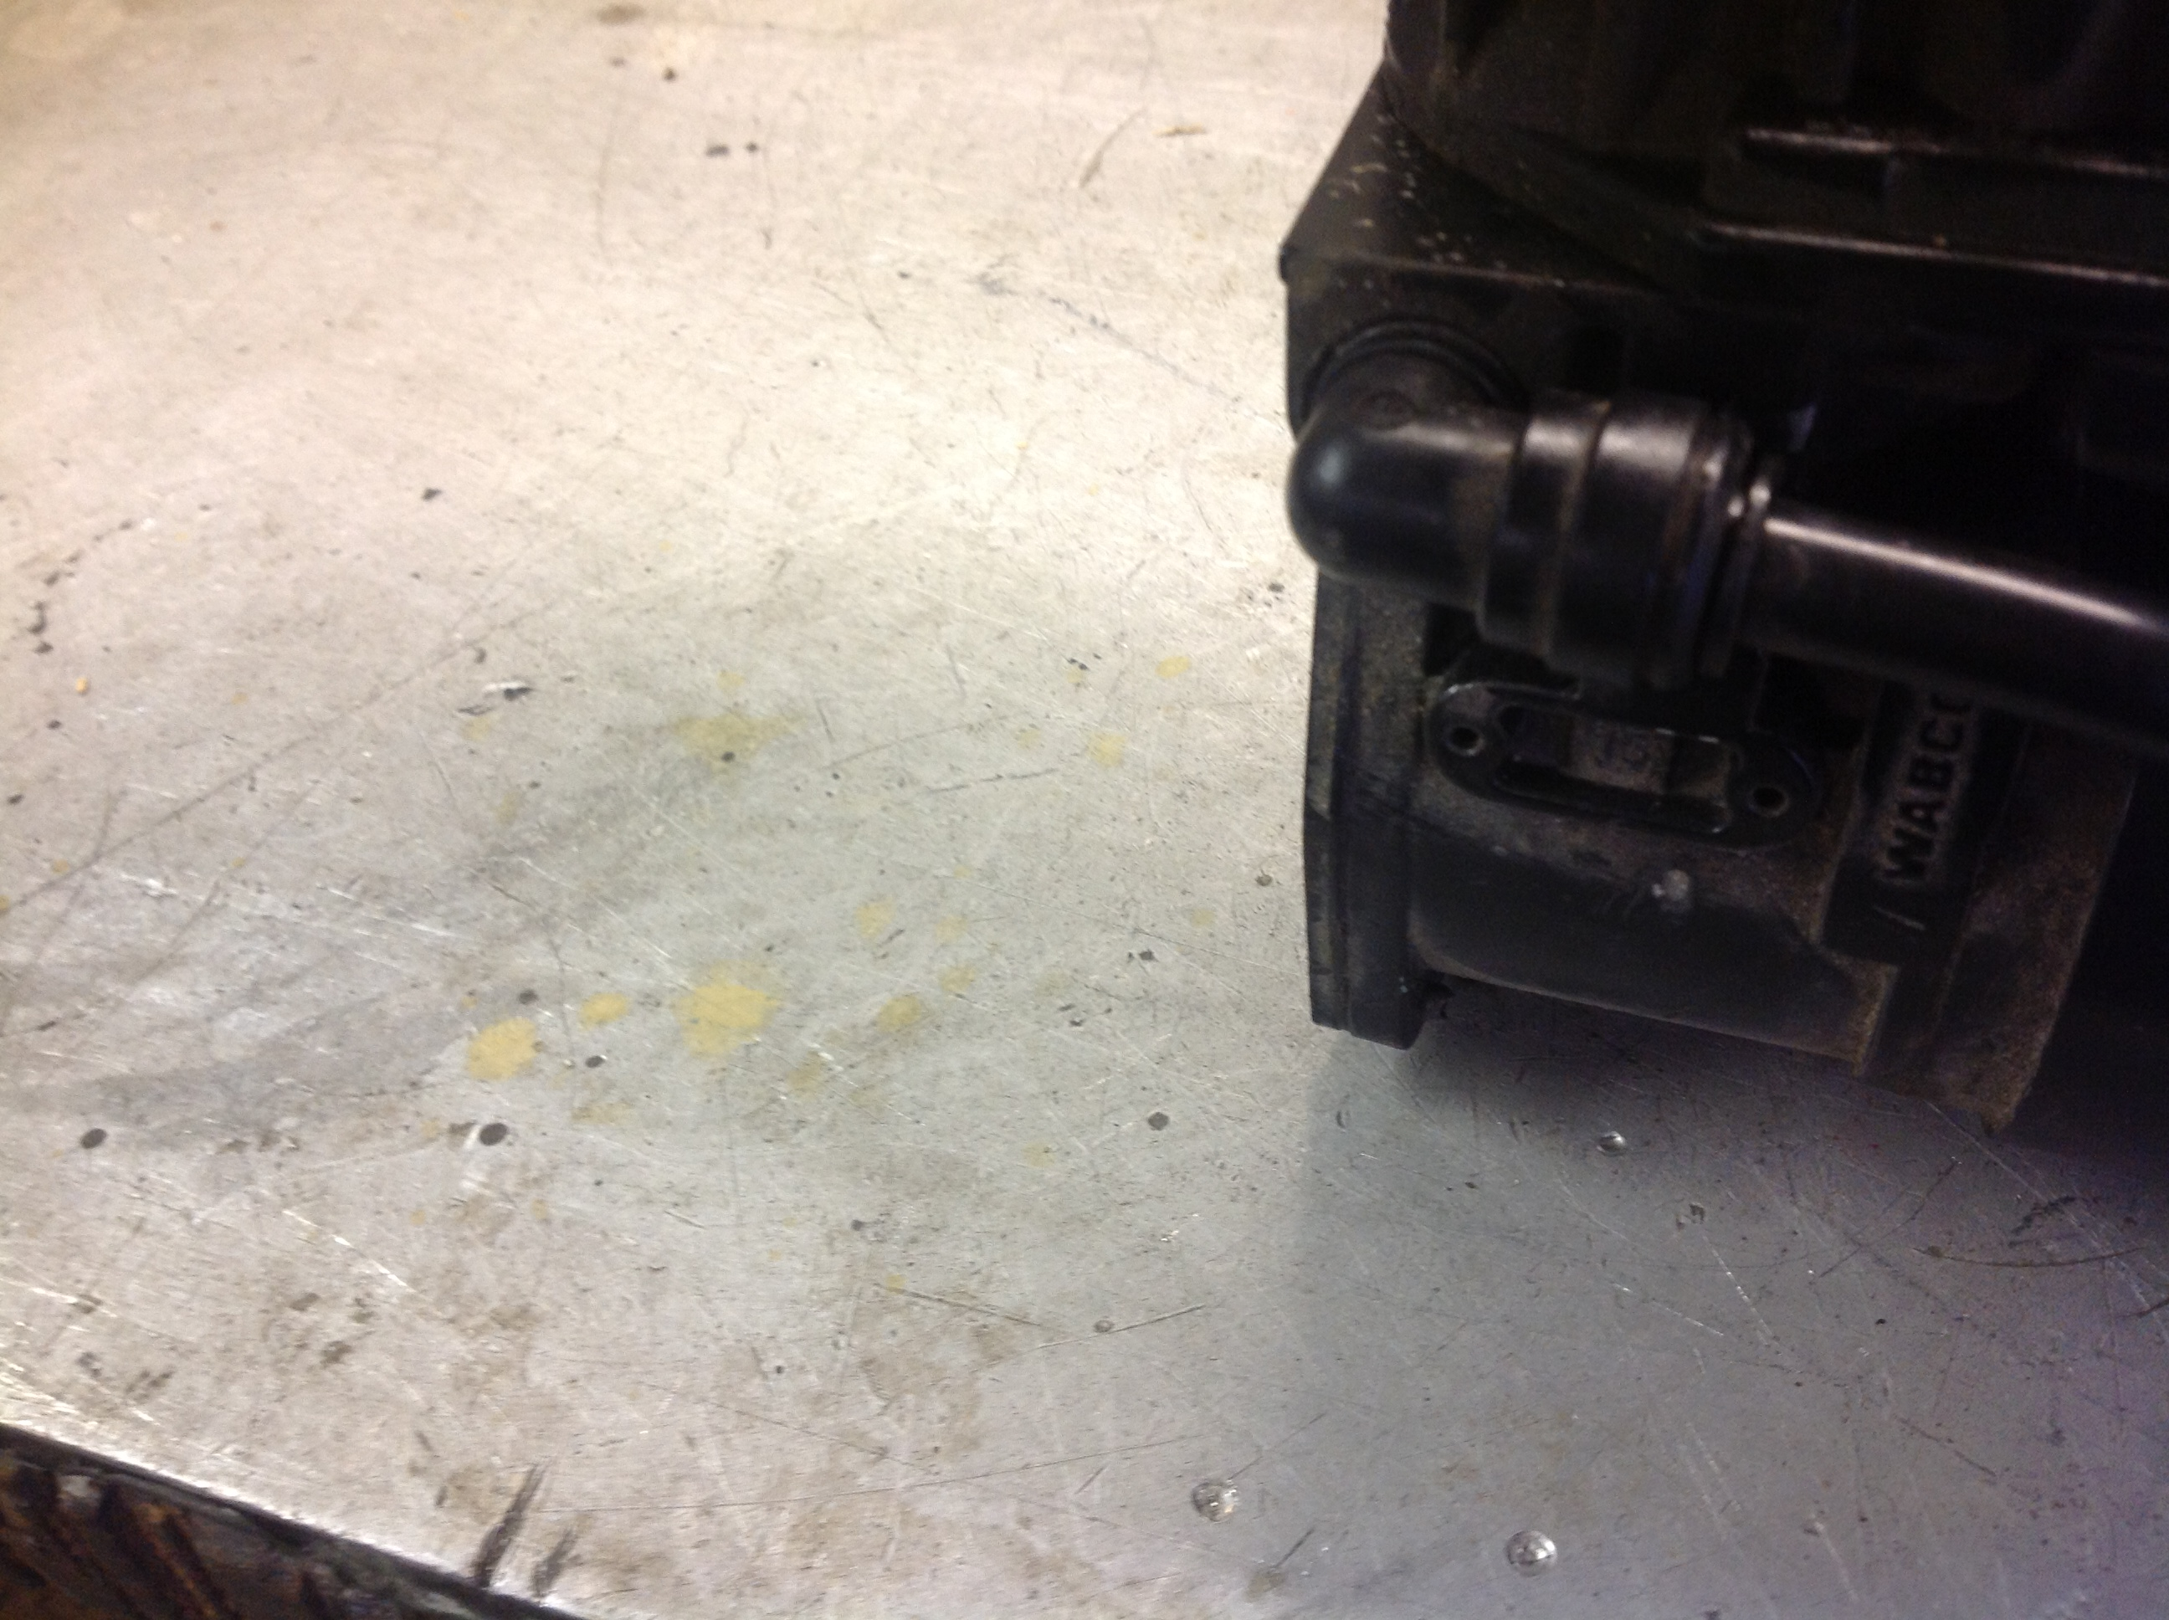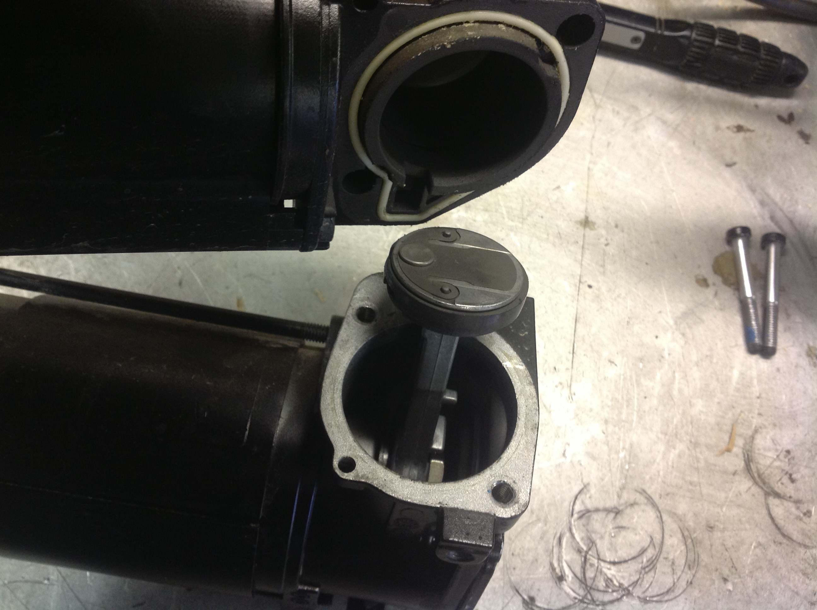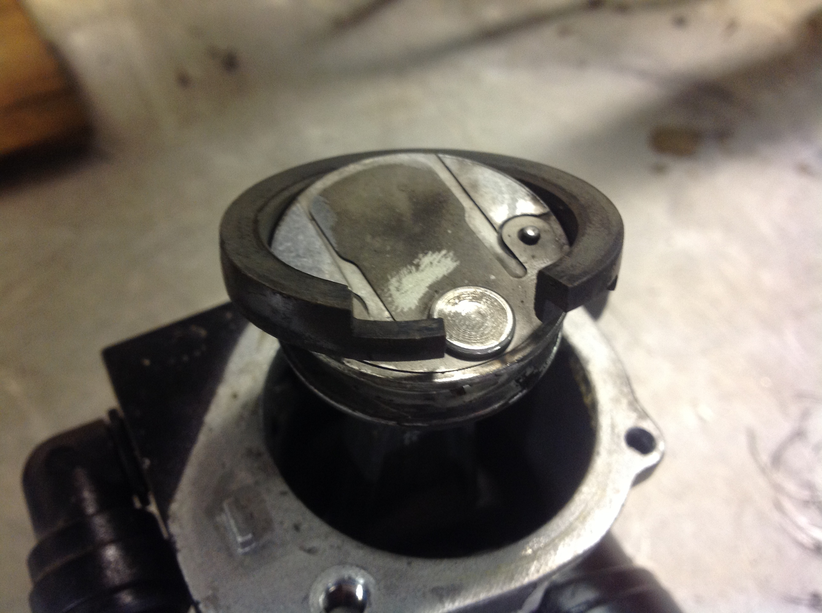
photo 1 photo 2 photo 3

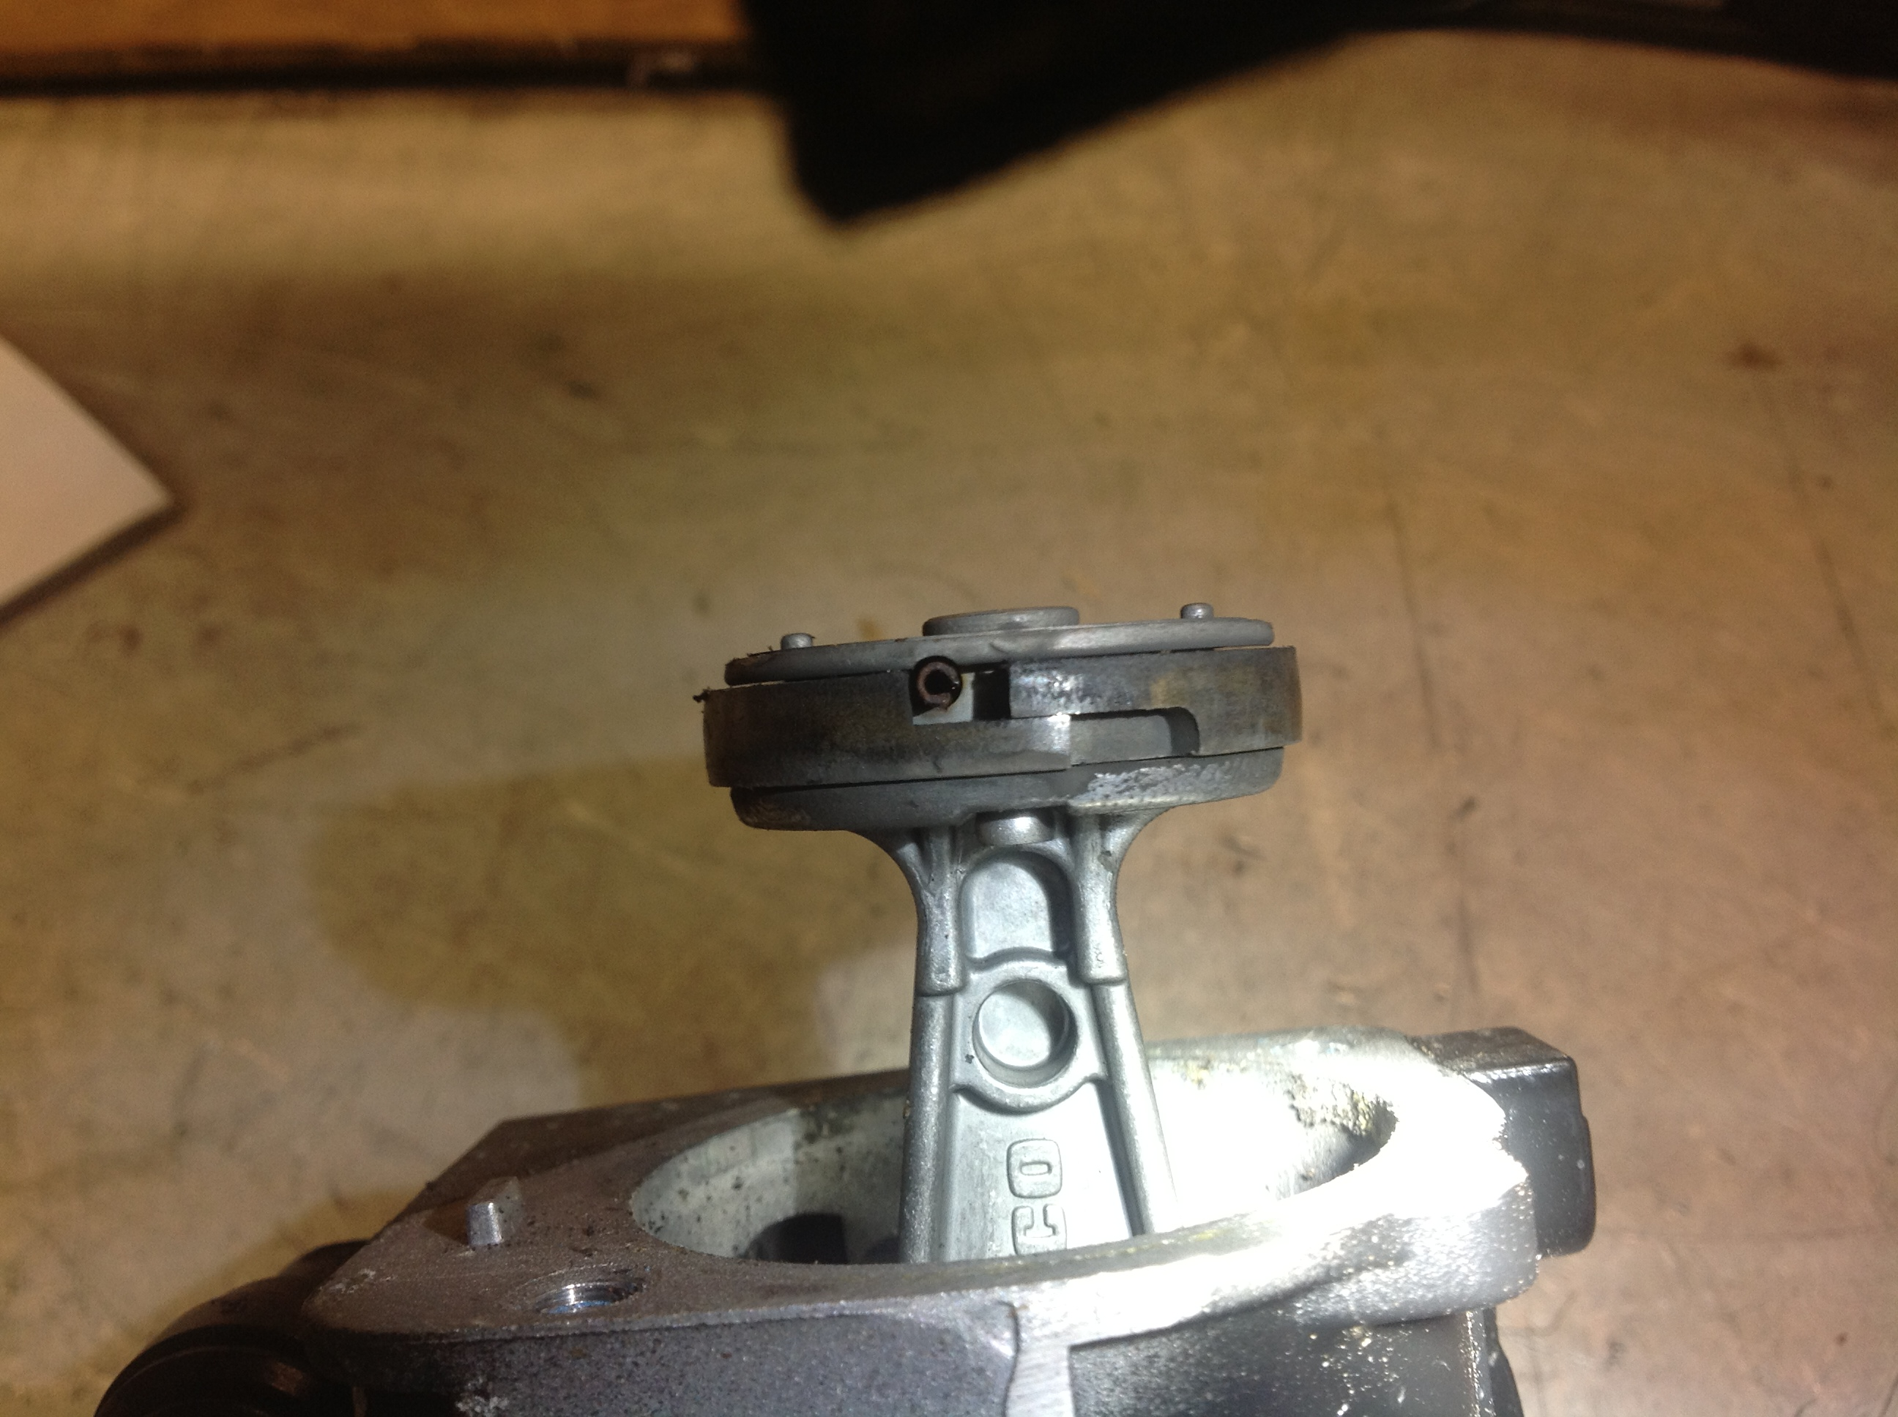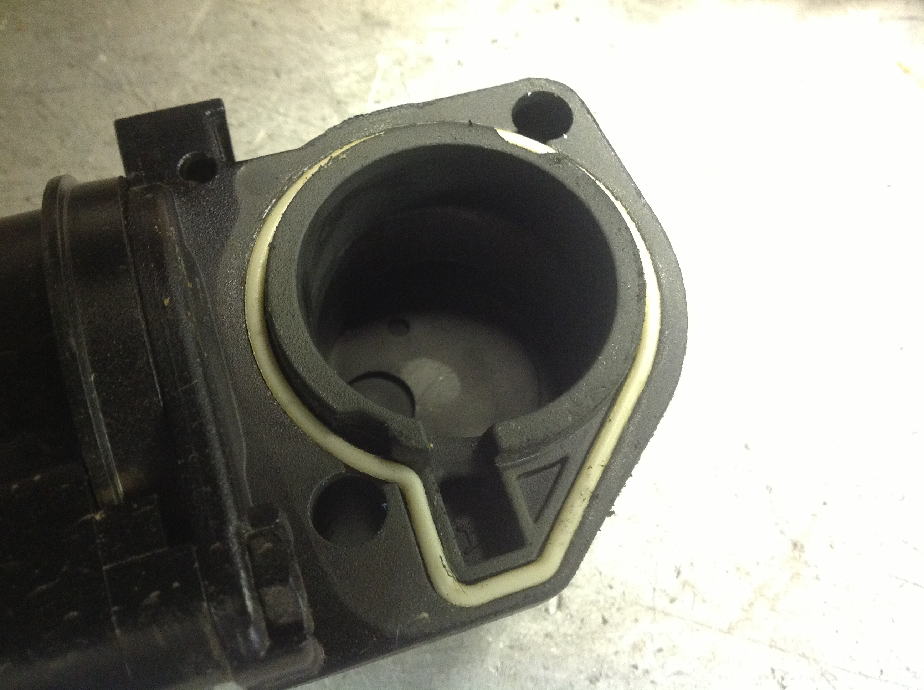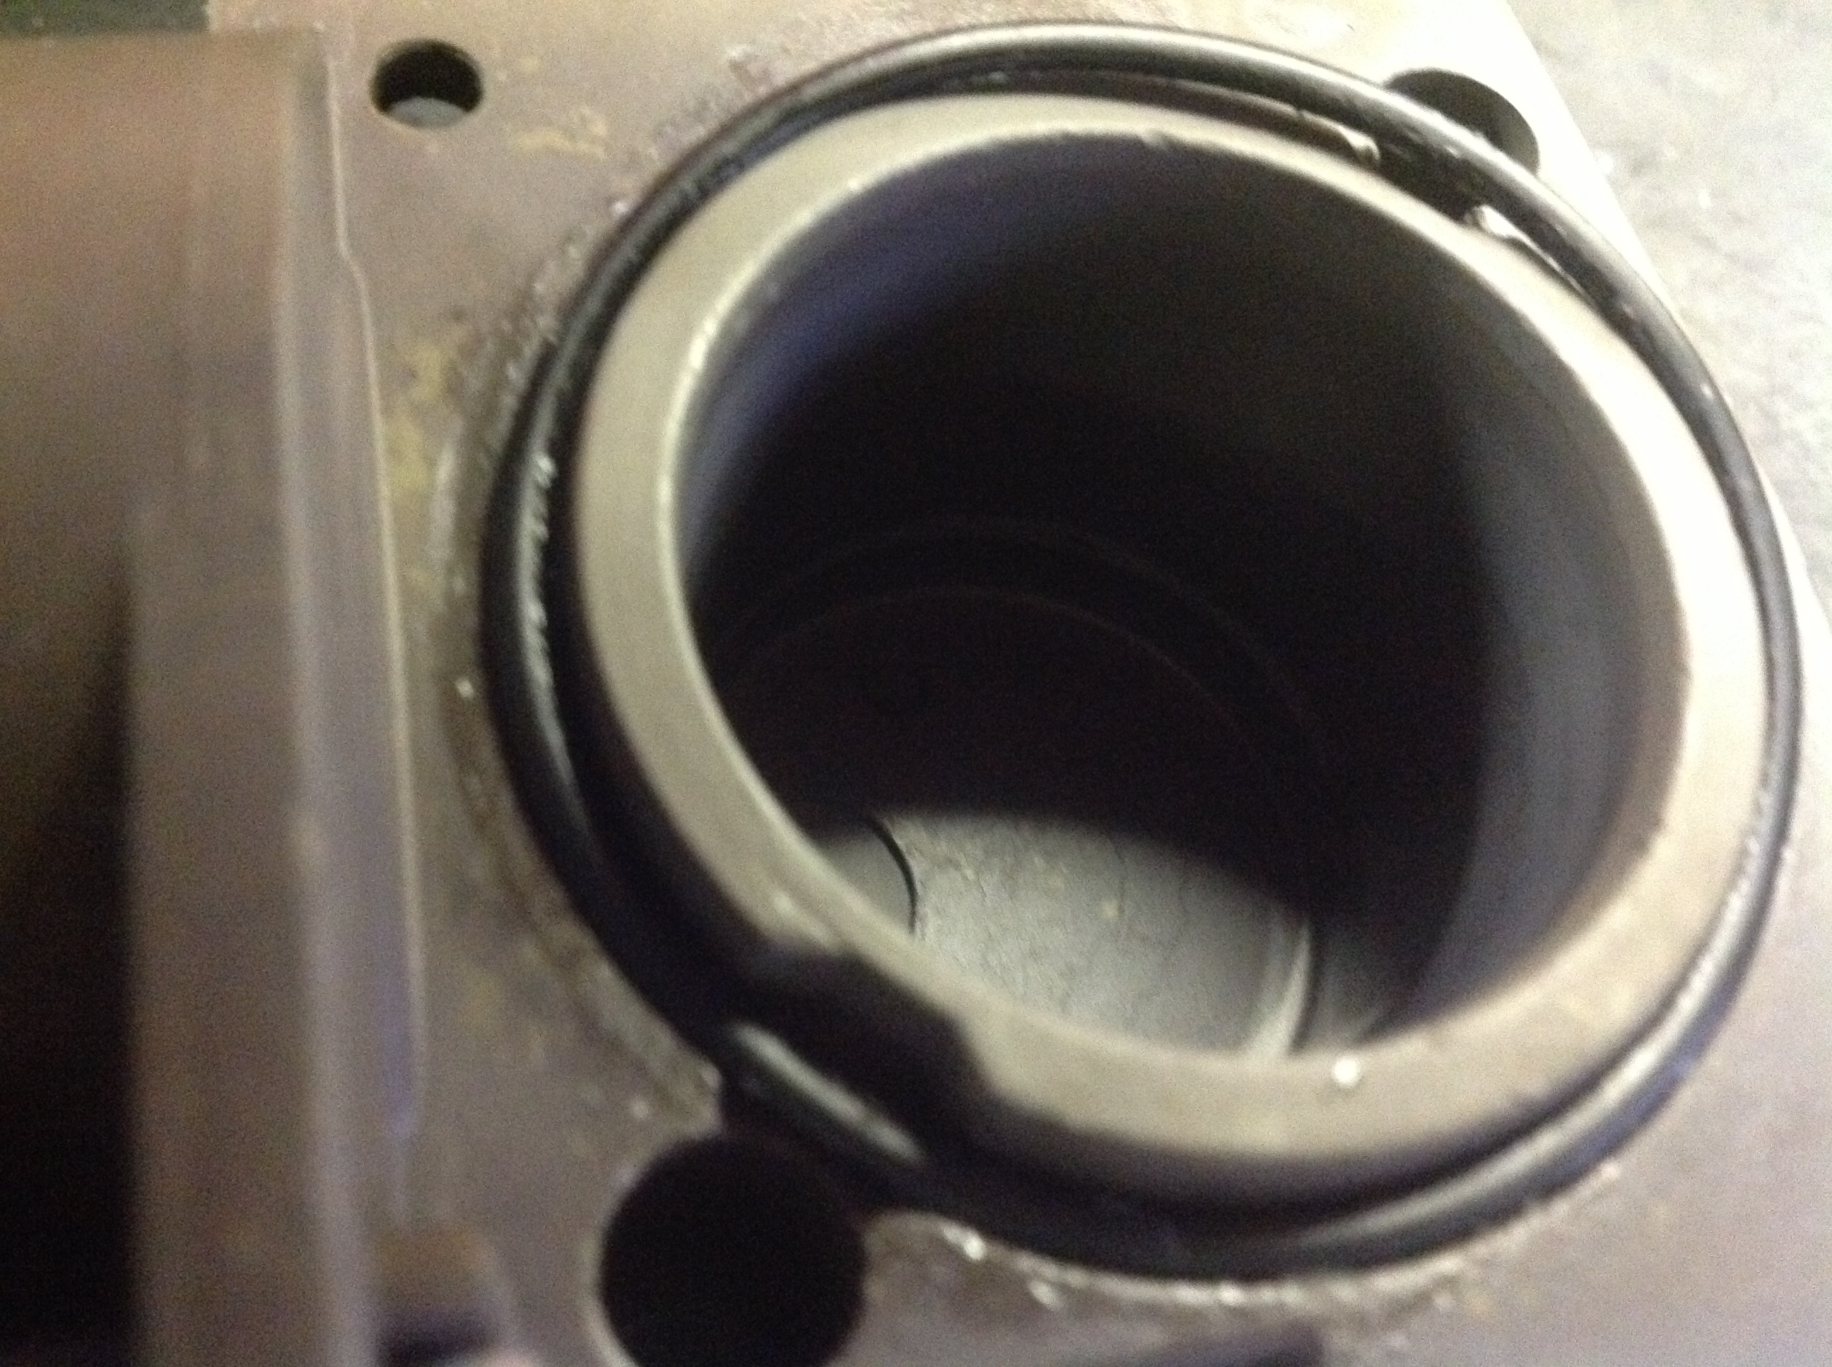
photo 4 photo 5 photo 6

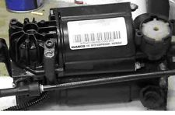
photo 7

Note
Please note these instructions are to be used as guide only and steps should be taken to familiarise yourself with your own vehicles onboard systems, model & specification which may or may not be affected with this particular type of repair procedure which could involve the disconnection of the battery, this particular repair item is used on many different types of vehicles of different manufacture ! disconnection of the battery can result in a visual alarm message appearing on the dashboard when the battery is reconnected depending on Vehicle model !on most occasions can be reset by consulting your owners manual or it can be simple matter of switching your vehicle off & then back on again ! in some instances a visit to a diagnostic repair centre to reset a particular Hard stored message may be required, i would recommend consulting website forums to satisfy yourself of the points above. On our website in the Technical Section there are videos on fitting this types of seal in a similar compressors ( L322 Range Rover )
including a video on installing Air Dryer filtration Repair kit.

Removing Compressor from vehicle ( based on Audi Allroad C5 )

1 Select Jacking Mode : press & hold both up & down height level buttons for approx 5 seconds .
2 Raise the rear of the vehicle & secure with axle stands or ramps
3 Locate & remove the 10mm nuts securing the compressor protective cover plate which is a perishable item & you may find that it could be missing alltogether
4 Upward fashion unclip the 3 electrical connections to the motor ,temp sensor,& solenoid valve
5 Cut the cable ties where necessary to aid the removal process ( new cable ties supplied)
6 Remove the 4mm air pipe from the end of the compressor by locating and unscrewing the brass fitting ! keep the brass fitting and component parts in a safe place .
7 Undo soft rubber intake pipe going to the compressor , this can be achieved in various places , if you prefer to remove the rigid plastic hoses at this stage pull gently on the pipe while pushing the securing collar inwards.
8 Locate 3 off 10mm nuts which the compressor is mounted , carefully remove the mounting springs / sleeves & washers and note there order to aid refitting later.

PISTON RING REPLACEMENT
1 Ensure the area to be dismantled is clean and free from debris which could enter the unit resulting in further problems, remove plastic intake pipe if not already removed by pulling gently on the pipe while pushing the collet inwards ( the elbow or T fitting should remain attached to the compressor ) See(photo 1 or photo 7 Yellow arrow).
2 Please note the position of the temperature sensor securely fitted to one of two cylinder head torx bolts ,temperature sensor indicated by( green arrow photo 6) , torx bolts indicated by red arrows ( photo 6)
remove torx bolts.
3 Remove compressor assembly off the motor with gentle leverage note the rubber seal (photo 2 red arrow).
4 Note the orientation of the old piston ring in relation to the locating pin pictured (photo 4 blue arrow).
5 Remove the old piston ring by stretching it over the connecting rod piston head pictured in (photo 3)
6 Ensure the piston ring groove is free from dirt and grime or residue dust from the old piston ring before fitting the new seal this also applies to the crank housing ! if you are feeling particularly brave ! some pumps have a face plate riveted to the front which can be removed which will allow extensive removal of old piston seal dust from the housing brake parts cleaner aerosol is particularly useful for this purpose ,you will then have to re- rivet the face plate back otherwise just use an air line and try to maximise dust removal with a face dusk mask of course .Fit your new seal the same way it was removed in relation to the locating pin ,when fitted close the seal with your fingers and visualise that the piston seal locating pin is postioned correctly and that the new piston ring can have a spring type feel opening and closing slightly.
7 Clean the cylinder bore and mating surfaces and if your pump is fitted with a round o ring seal pictured in photo 6 purple arrow then replace this with the new one supplied in the kit , if your compressor as a shaped o ring seal ( photo 5 black arrow) then re-use that seal .
8 Before refitting the cylinder head housing back over the piston you can coat your new piston seal with a slight smear on the outside diameter of the seal with the special lubricant supplied in the kit this will help your new seal to bed in so to speak.
9 Refit your compressor bore housing assembly over the newly fitted piston seal and secure it with the 2 new bolts supplied in the kit ! not forgetting to attach the temperature sensor in the same position as it was removed (photo 7 green & orange arrows) !Do Not Over Tighten the bolts.
10 Refit the compressor back on your car following above steps in reverse , use cable ties supplied to resecure cables in there correct place.

===================================================================================

LandyAir - Wabco Air Dryer Filtration Repair Kit

This kit can be fitted in Air suspension compressor Air Dryer Units from vehicles: Jaguar xj8 2003-2007, Range Rover l322 2002-2006 ,Land Rover Discovery 2 ,Audi Allroad 2000-2005 ,Mercedes S class + many more models.
Please go to our website www.landyair.com ! technical section and view the video fitting instructions for this kit or go to You Tube and key in Landyair201309B.
Picture 1 picture 2 picture3
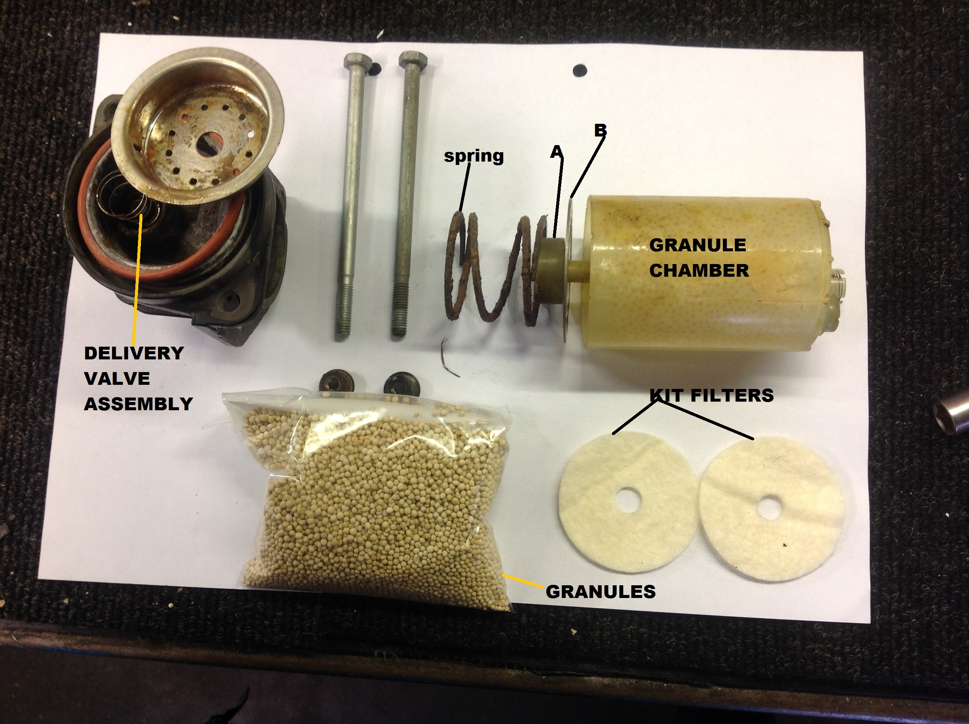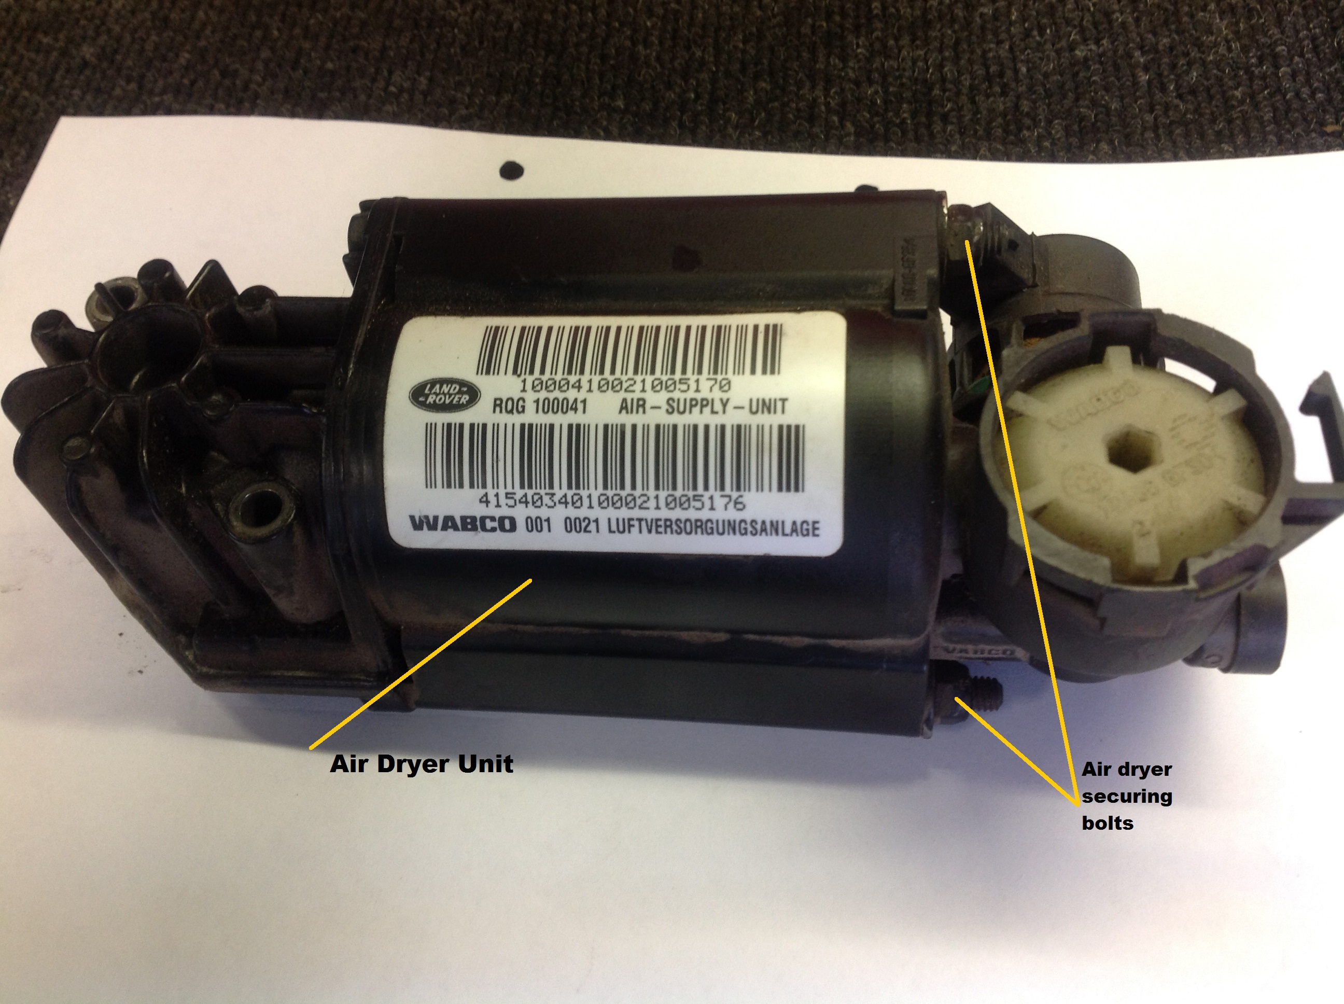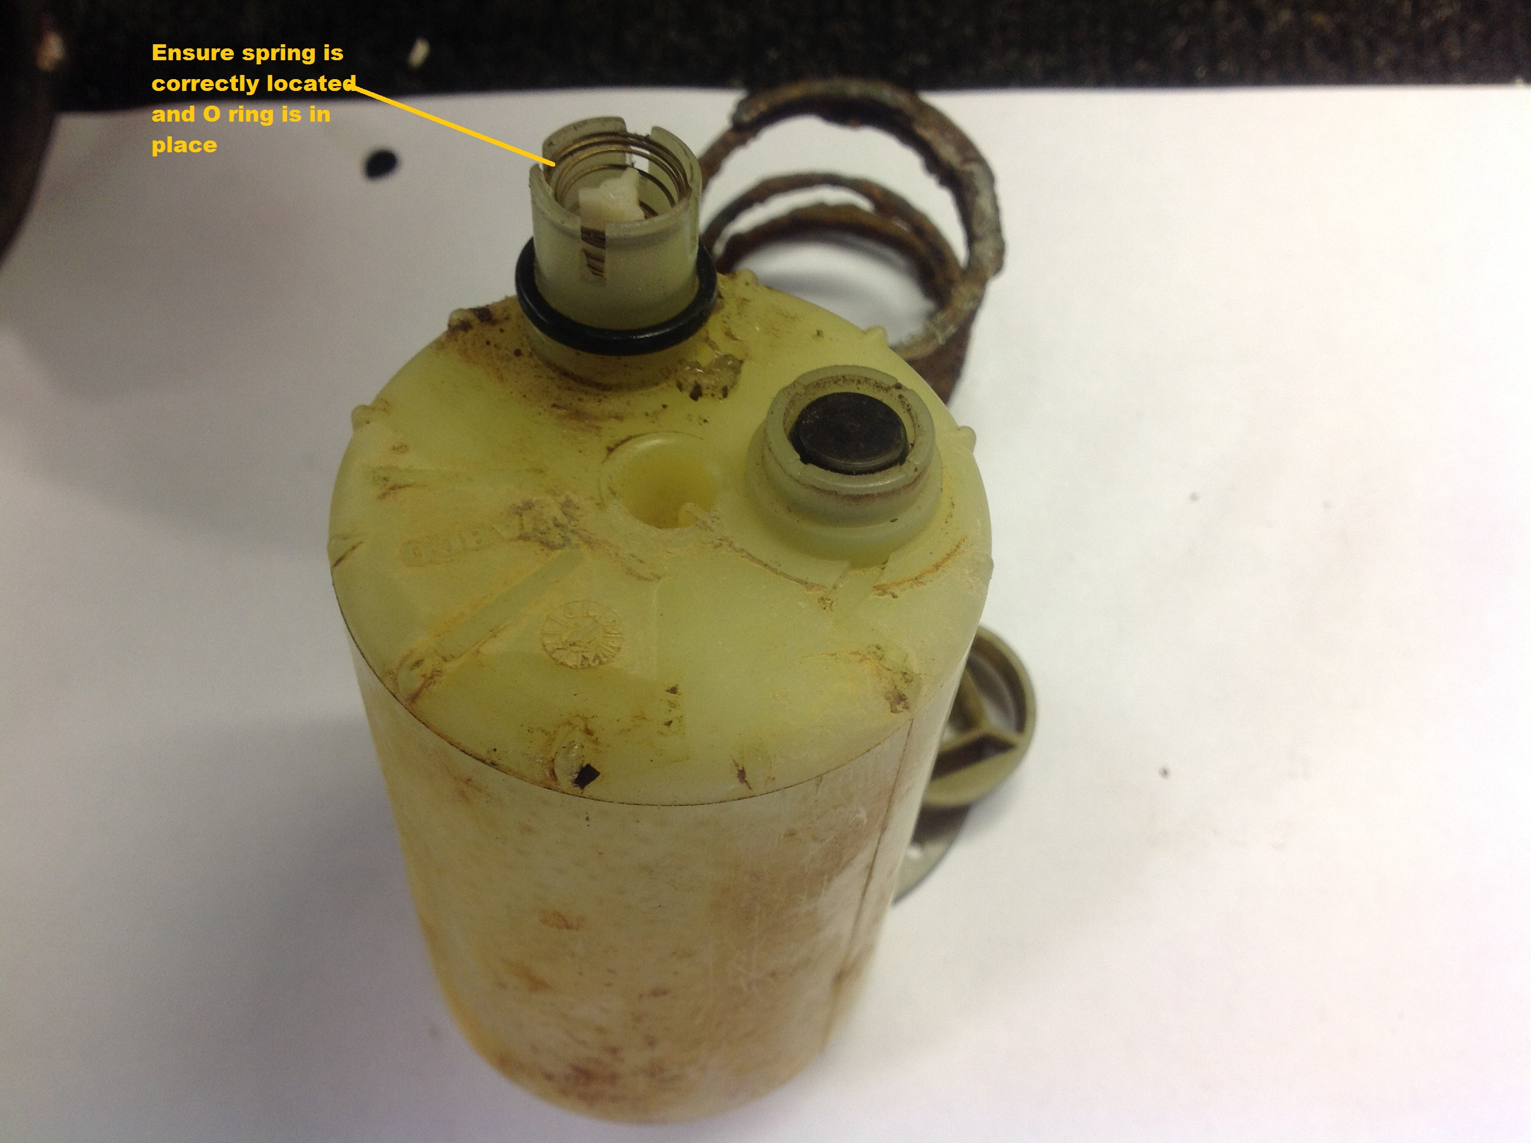
picture 4
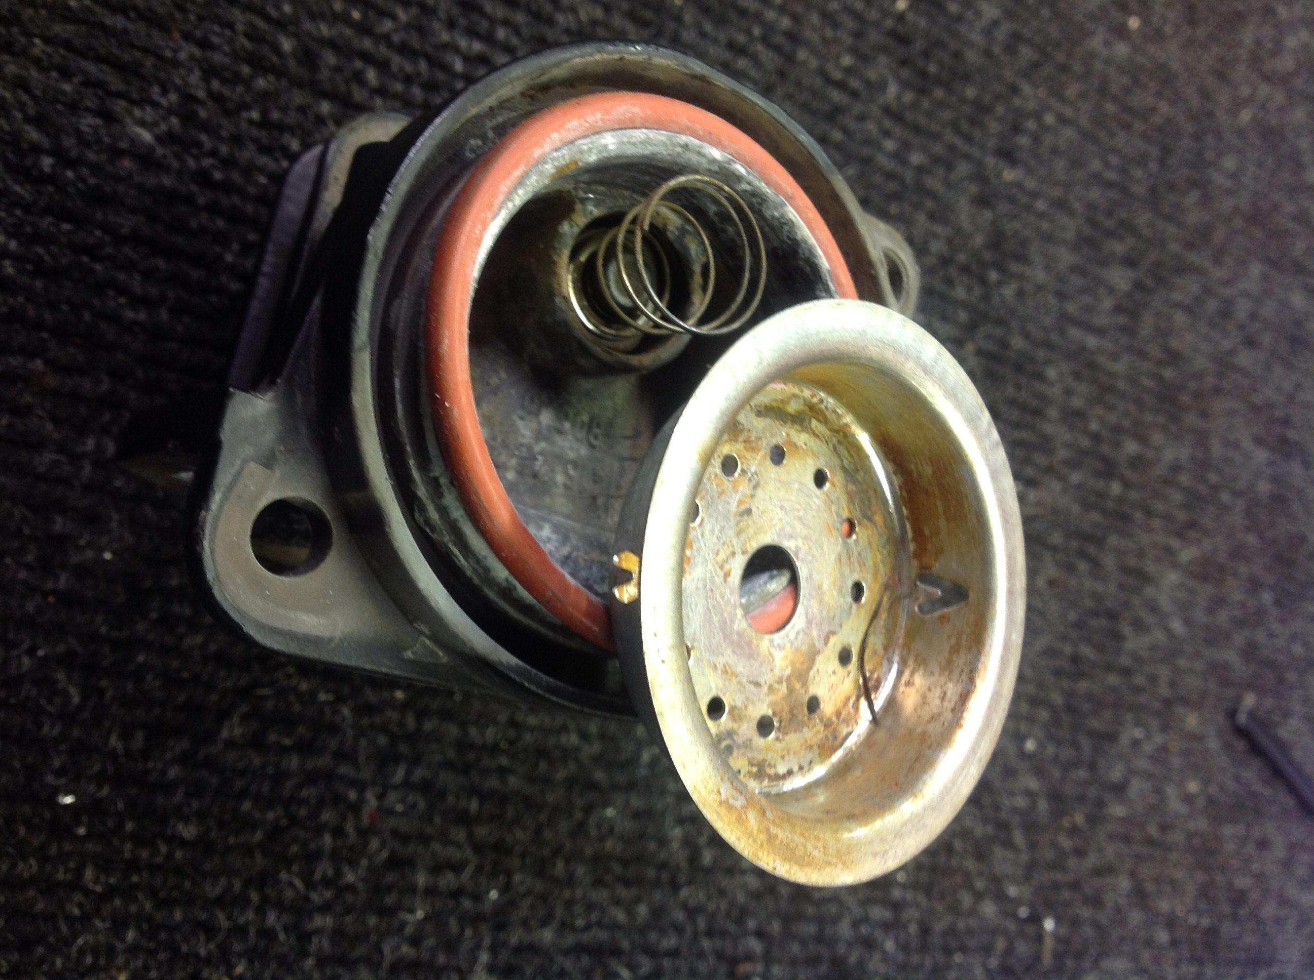

Picture 2 Remove 2 off nuts securing air dryer unit to the cylinder head unit then seperate the air dryer from the cylinder a spring will assist as you disassemble .

Picture 1 At this stage you will be holding the air dryer in your hand, first step is to remove item A by pulling it of the spigot ,then position a suitable container on your bench tip the contents of your air dryer into the container, the metal filter plate will need to be recovered from the medium as we will be re-using the plate.

There is no need to remove the granule chamber from the housing as illustrated in picture 1 , clean out the chamber free from condensation and old granules ,using thin nosed pliers pull out the filter pad in the bottom of the chamber ! making sure there are no loose granules to block any air holes in the bottom. Fit 1 of your new filter pads into the bottom of the granule chamber, with your finger over the granule chamber centre spigot, tip your new bag of granules into the chamber !slowly until they appear near the top of the chamber , settle the level of the granules then fit your remaining filter pad on top of the granules then place the metal filter plate on top of the pad securing it by refitting item A which is placed hard up onto the face of the metal filter plate this will avoid the contents of the air dryer from falling out while you assemble/inspect the remaining parts.

If you prefer to disassemble the cylinder head and air dryer housing to a more advance stage for cleaning purposes then please refer to pictures 1 ,3 , 4 which clearly show the breakdown of parts , the delivery valve assembly in picture 4 and flow valve assembly in picture 3 require particular attention that you do disturb fitting of these parts.

=================================================================================

